


VEHICLE SPEED AND DENSITY ESTIMATION USING DEEP LEARNING ON CCTV FEEDS
Machine Learning Project
UNDER THE GUIDENCE OF


Raghavendra

TEAM MEMBERS

01.
Sharanya Reddy
2520030277

02. Renuka
252003176





INTRODUCTION

With the increasing number of vehicles, traffic congestion and speeding have become major challenges. Traditional monitoring methods can be costly and time-consuming. This project uses existing CCTV cameras with deep learning to automatically monitor vehicles, estimate their speed, and analyze traffic density.

PROBLEM STATEMENT
Traditional traffic monitoring often depends on manual observation or additional sensors, making it difficult to monitor large areas continuously.
Our solution:
Use CCTV footage and deep learning to automatically detect vehicles, track their movement, estimate speed, and determine traffic density.



PROPOSED SYSTEM
The system takes CCTV footage as input and processes it using deep learning and computer vision techniques. Vehicles are detected and tracked across consecutive frames. Their movement is used to estimate speed, while the number of vehicles in a defined road area is used to calculate traffic density.




TECHNOLOGIES USED
Python
YOLO
OpenCV
Deep Learning
Computer Vision
CCTV Camera / Video Feed Deep Learning Frameworks

METHODOLOGY
CCTV Feed → Vehicle Detection → Vehicle Tracking → Speed Estimation → Vehicle Counting → Density Calculation → Traffic Classification
YOLO can be used for fast and accurate
vehicle detection, while tracking techniques follow vehicles between consecutive frames

Road safety monitoring Traffic congestion analysis
02
APPLICATIONS
Smart city traffic monitoring Traffic control centers
01

03
Intelligent transportation systems CCTV-based traffic management

Output

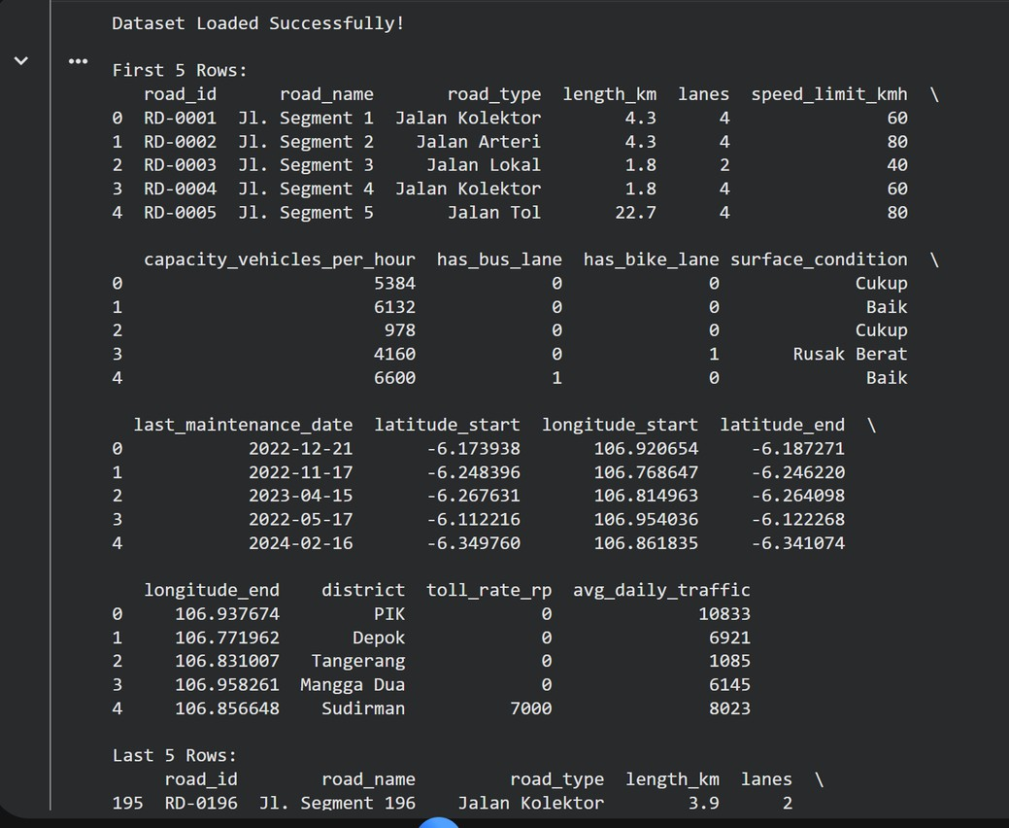
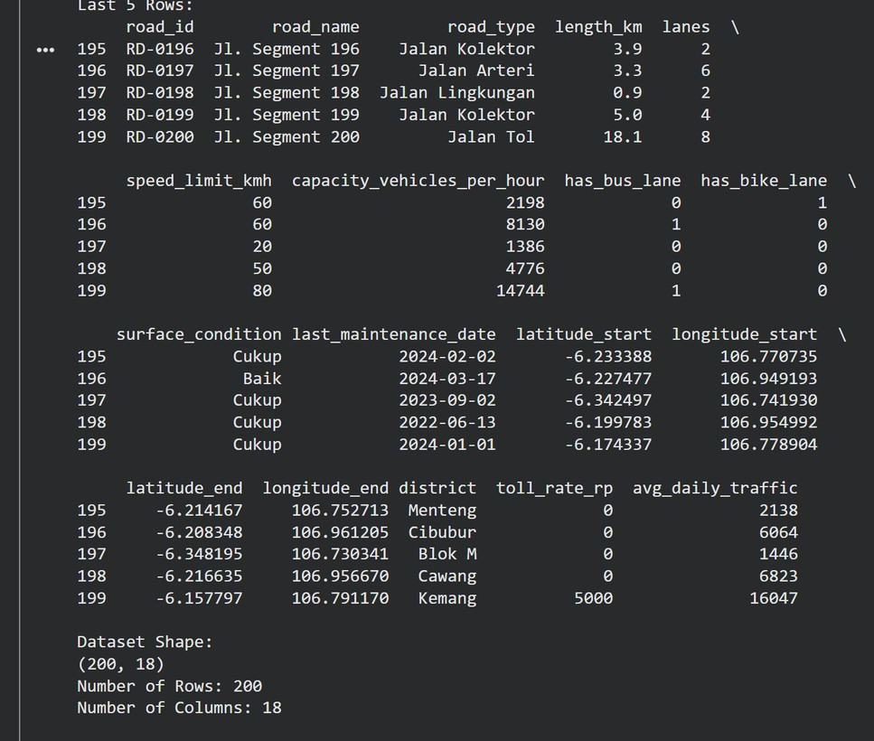

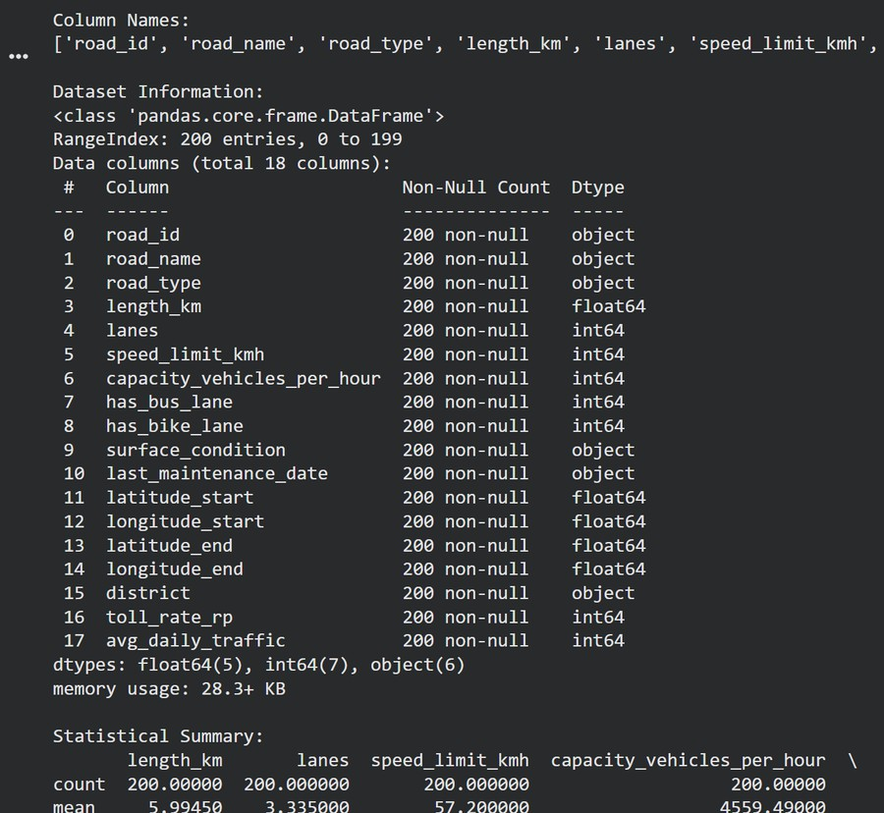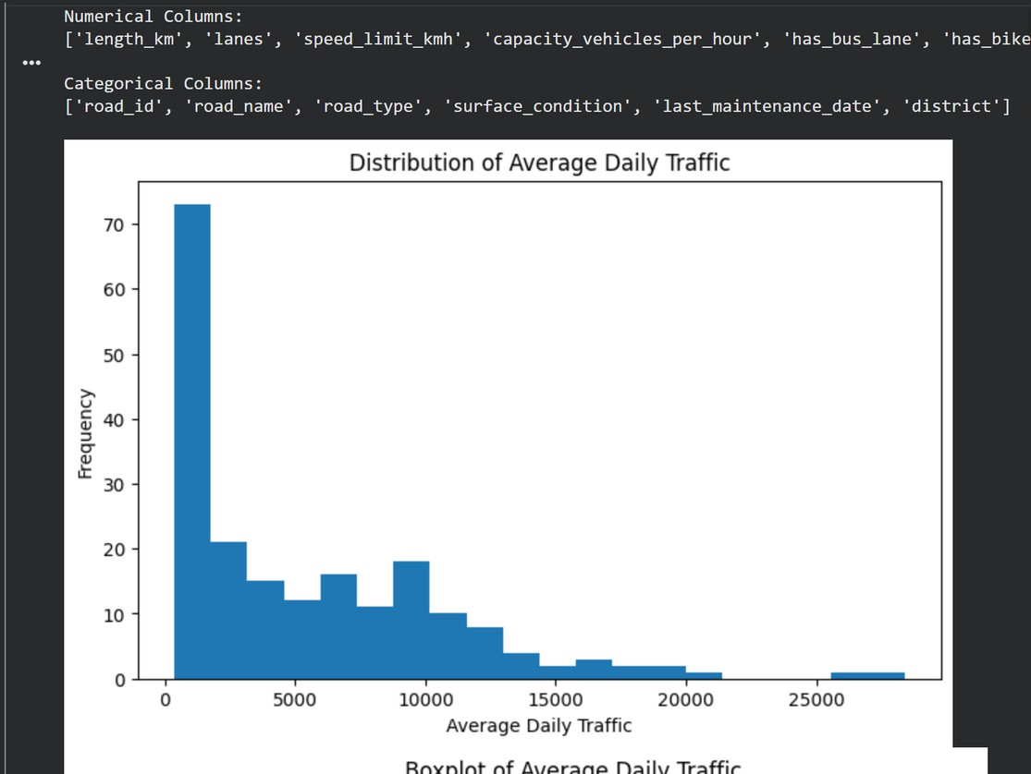

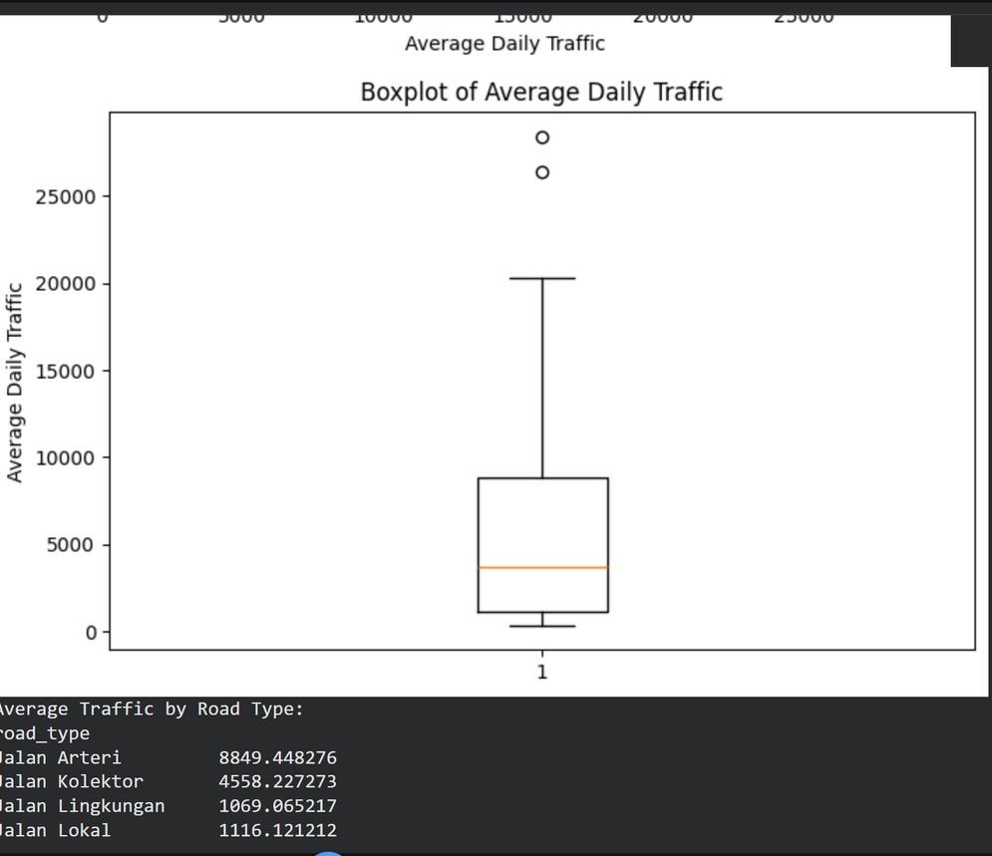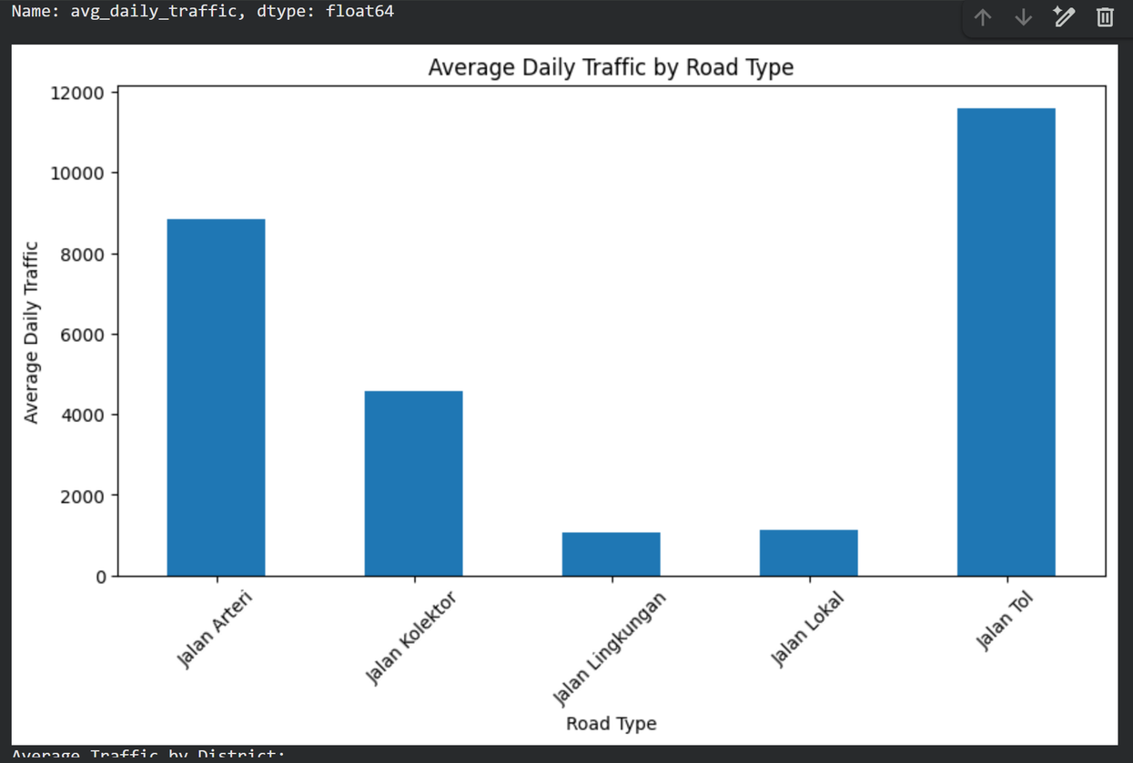

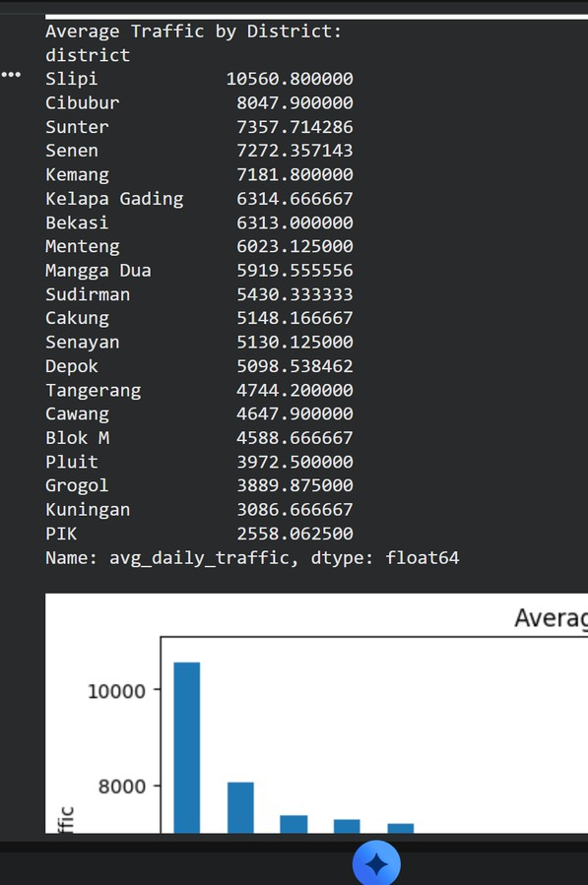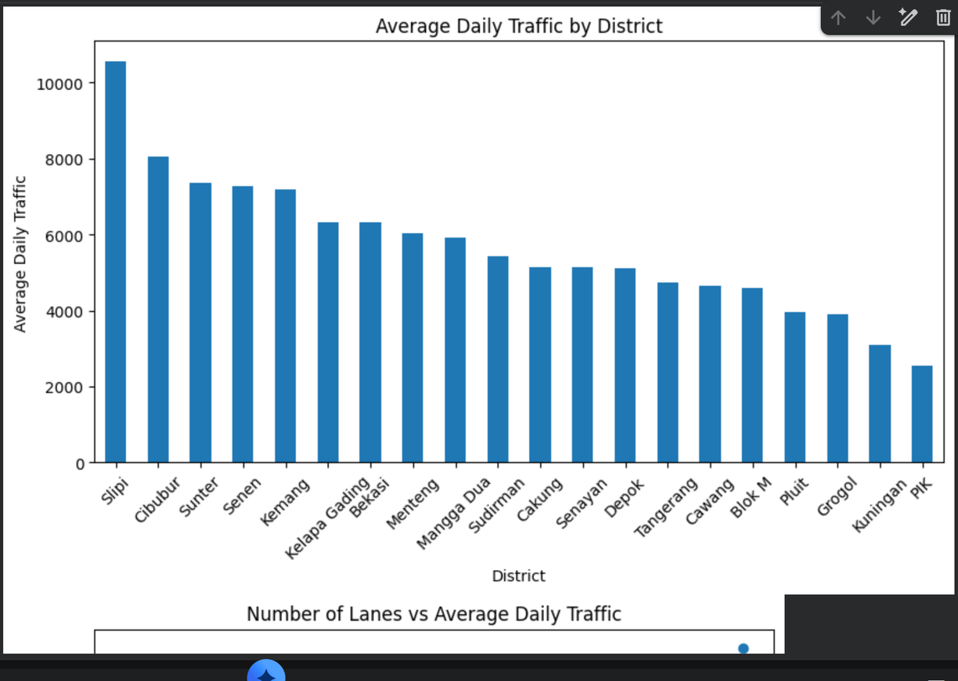

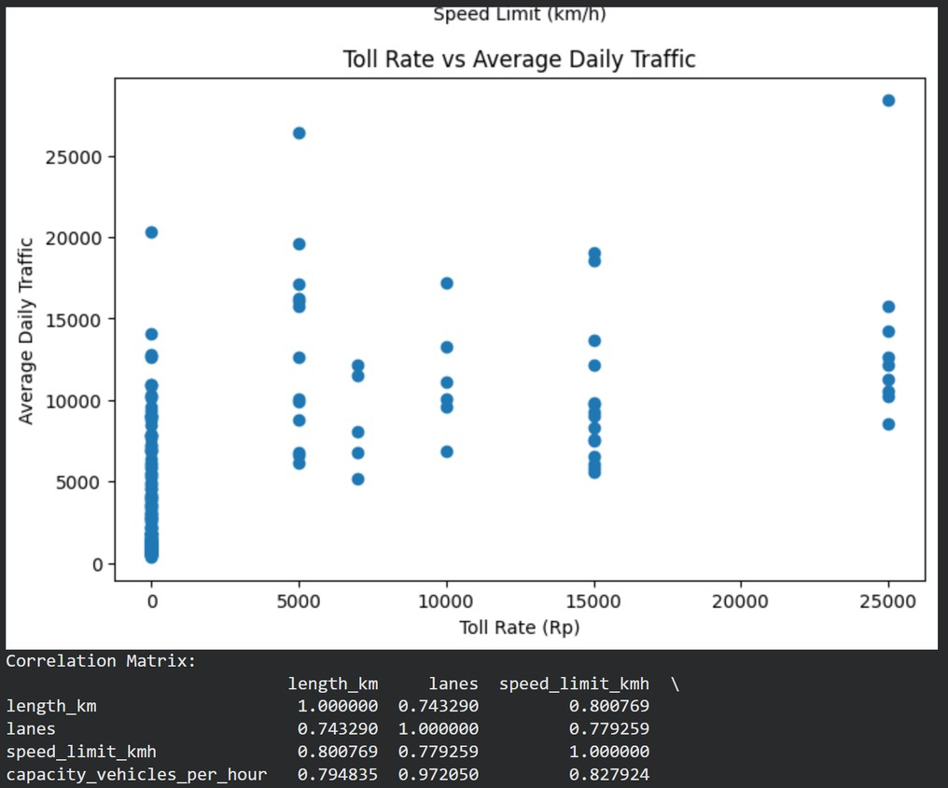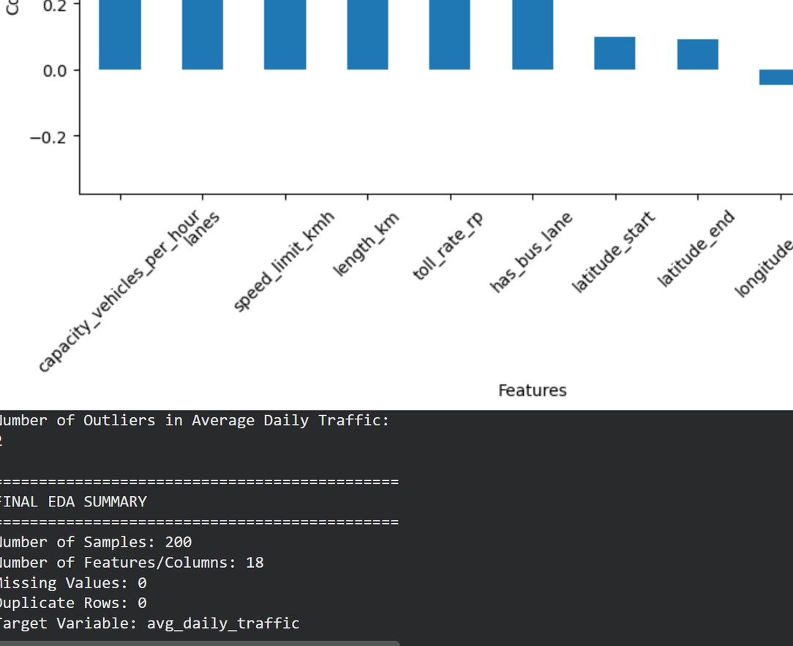

Literature
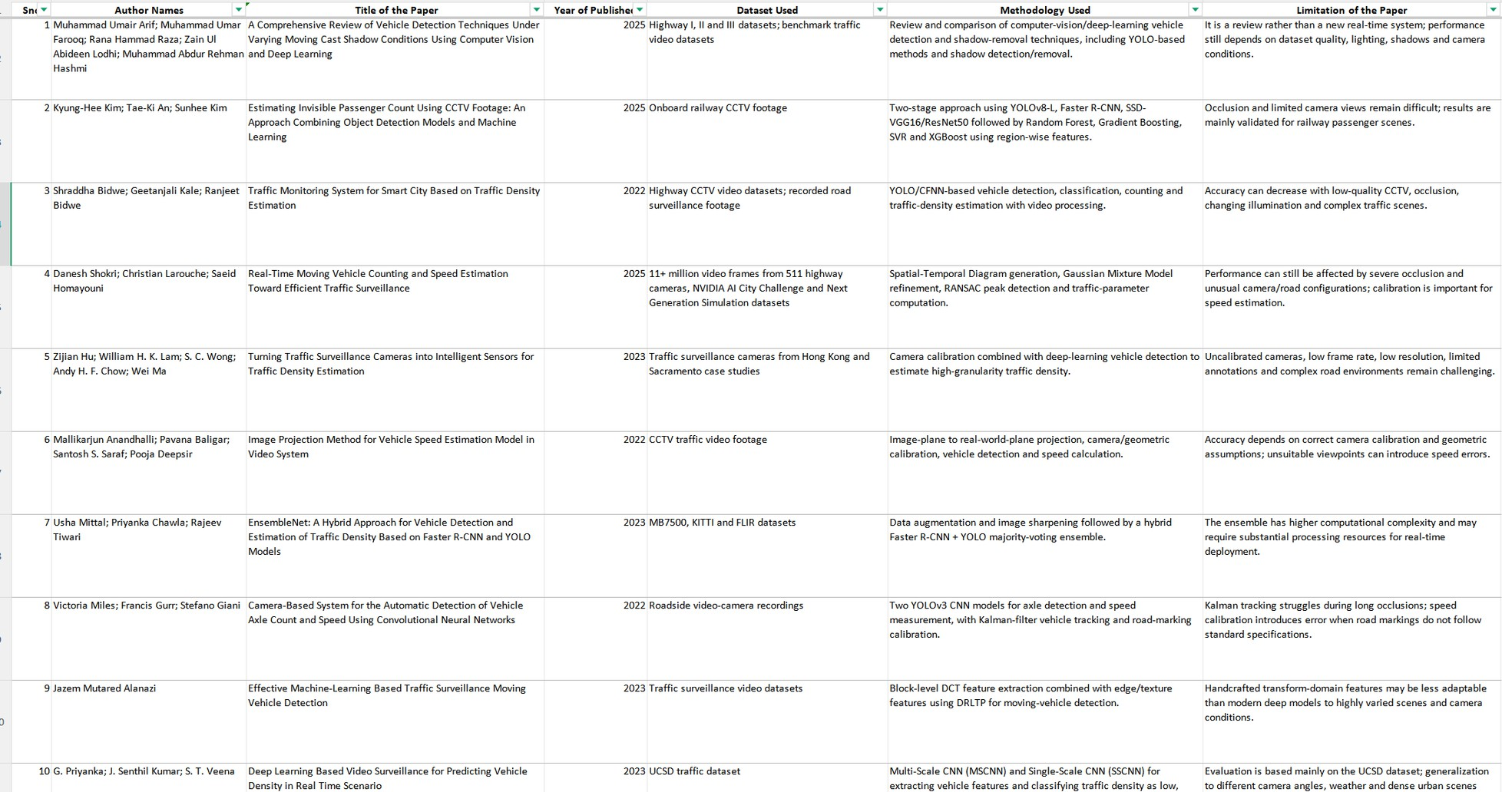

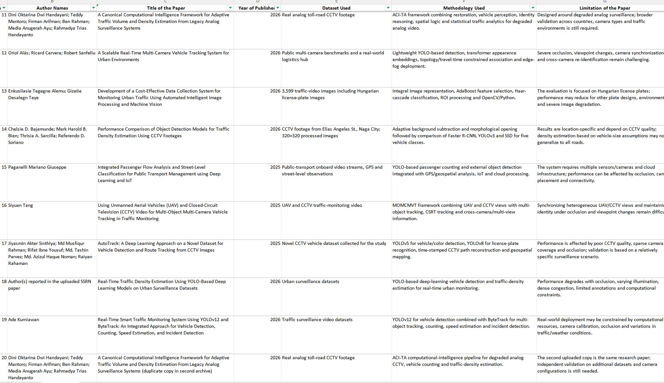

CONCLUSIONS

This project demonstrates how deep learning and computer vision can be combined with CCTV feeds for automated traffic monitoring. By detecting and tracking vehicles, the system can estimate speed and traffic density, providing useful information for safer and more efficient traffic management.

THANK YOU VERY MUCH!

